2. SAIFA Structure and the Role of the AI Gateway

2.1 SAIFA as a national AI Factory Antenna
SAIFA is designed as a national single entry point for AI services, computing resources, data, models, tools, training and expert support. The AI Gateway provides the common user-facing access layer, while the underlying capabilities are delivered through the project infrastructure, sector-specific applications, support services and links to European AI Factory resources. This arrangement reduces fragmentation and enables users from research, industry and public administration to follow structured paths from initial exploration to validated AI workflows.
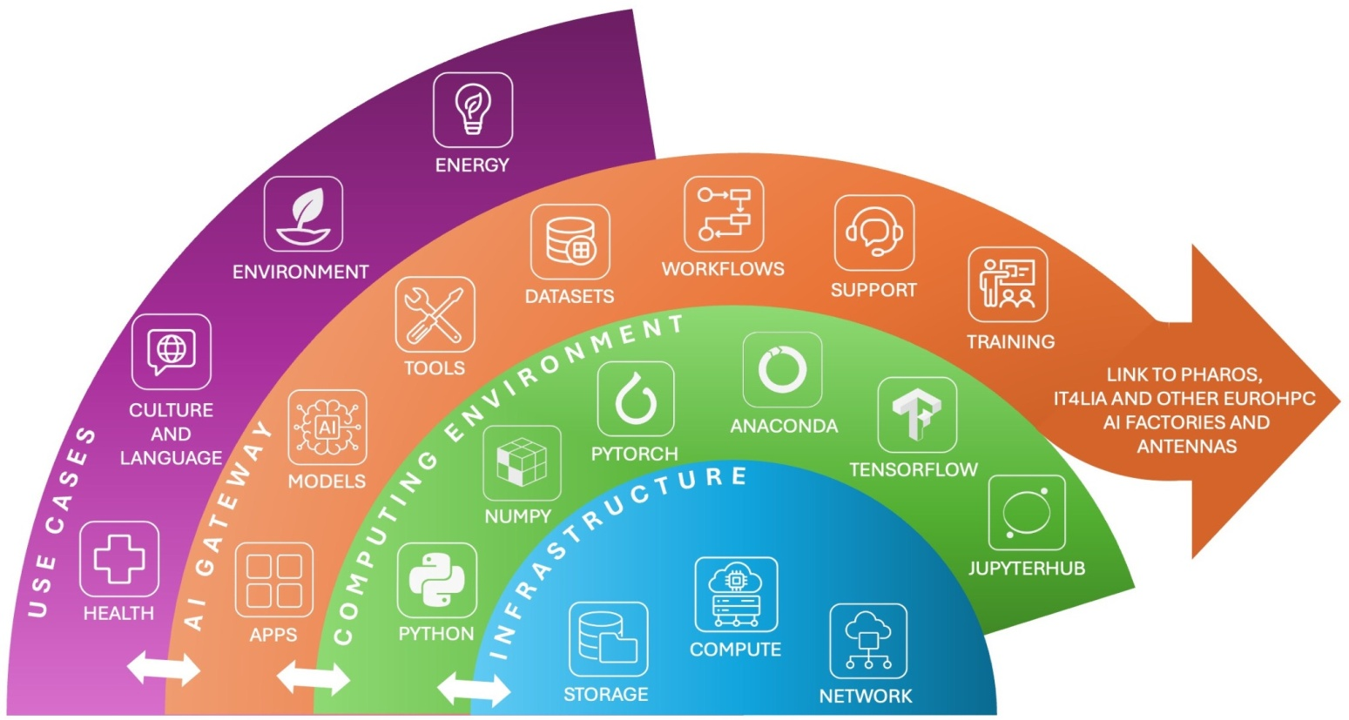
Figure 2.1. Overview of the Serbian AI Factory Antenna structure.
2.2 National infrastructure and computing environment
SAIFA uses the PARADOX HPC cluster operated by IPB and the AI computing infrastructure operated by ITE for development, integration and preliminary testing. Both provide dedicated computing time and storage for project activities. The planned 100 Gbps connection between the IPB and ITE data centres, established with AMRES, supports efficient transfer and synchronisation of project data. Final validation and performance testing will also use the Greek and Italian AI Factory infrastructures in accordance with the access and interoperability arrangements developed in WP3.
Existing scheduling and resource-management systems will be adapted to support priority-aware and workload-aware allocation. Users will submit jobs with defined CPU, GPU, memory and runtime needs, while the underlying schedulers remain responsible for queue management, backfilling, quality-of-service policies and fair use of the available capacity.
The computing environment will support containerised execution so that applications and their dependencies can be reproduced across compatible platforms. Kubernetes-based services and the existing cluster schedulers may be used for different workload types. Curated images for widely used AI frameworks will simplify onboarding and provide repeatable starting environments.
Advanced users may also register approved custom environments when a domain workflow requires specific libraries or tool versions. The approval and execution process must preserve security, reproducibility and compatibility with the selected computing backend.
2.3 AI Gateway layer
The AI Gateway sits above the computing and data infrastructure as the unified access and integration layer. It provides structured discovery and access to applications, workflows, reusable tools, pre-trained models and AI-ready datasets, and connects these assets with execution environments. It also gives users access to development and consulting services, technical guidance, training modules and learning paths prepared in cooperation with WP5.
The Gateway also supports controlled collaboration. Users and teams may share authorised models, datasets, code and results under common identity, access-control, monitoring and audit rules. Domain applications remain owned by WP4 and the relevant service teams; the Gateway exposes them through consistent metadata, access and execution patterns.
2.4 Federation with European AI infrastructures
The Gateway provides the technical link between SAIFA, the Pharos AI Factory in Greece, IT4LIA in Italy, the AI-on-Demand Platform and other EuroHPC AI Factories and Antennas. The collaboration commitments described in the project documentation include:
- Model dissemination. Make validated and publishable SAIFA models discoverable through connected catalogues, with their origin, version and usage conditions preserved.
- Dataset contribution. Register AI-ready datasets in connected data catalogues where legal, ethical and licensing conditions permit publication or controlled access.
- Validation feedback. Share evidence from testing and validation of SAIFA services, workflows and tools to support interoperability and service improvement.
- Synthetic data exchange. Contribute synthetic datasets together with quality and applicability information where their release is approved.
- Service enhancement and documentation. Provide technical feedback, extensions, documentation and tutorials that improve the usability of shared AI Factory services.
- Training collaboration. Co-develop and reuse specialised training material with partner AI Factories.
- Promotion and outreach. Promote relevant partner services and training opportunities to the Serbian user community and support wider European dissemination.

Figure 2.2. Overview of the AI Gateway structure.

2.5 Target domains and project contributions
The AI Gateway supports the four principal application areas defined in WP4: language and culture, energy and manufacturing, health, and environment. These domains provide the datasets, models, workflows and validated applications through which the Gateway is tested. Cross-domain services such as cybersecurity, trustworthy AI, training, support and interoperability apply across all four areas.

